Task 2

1. How many products did you scrape?

**Ans : db.flipkart.countDocuments()**



1. How many products have a discount on them?

**Ans : db.flipkart.countDocuments( { $expr: {$eq: ["original_price", "sale_price"]} } )**



1. How many Topwear products don't have any discount on them?

**Ans : db.flipkart.countDocuments({ $and: [**

**{ "product_category": { $eq: "topwear" } },**

**{ $expr: {$ne: ["original_price", "sale_price"]} }**

**]})**

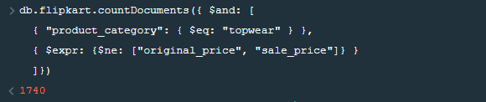

1. How many unique brands are present in the collection?

**Ans : db.flipkart.distinct('brand').length**



1. What is the count of discounted products for each brand?

**Ans : db.flipkart.aggregate([{$group : {_id : "$brand", count : {$sum : 1}}}])**

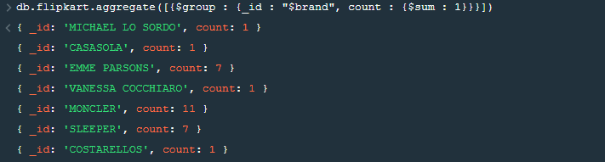

1. How many products have shirt in their name?

**Ans :** **db.flipkart.find( { name: /shirt/ } ).count()**

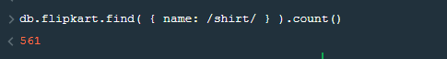

1. How many products have offer price greater than 300?

**Ans : db.flipkart.countDocuments({$expr: {$lt: [{subtract: ["$original_price","$sale_price" ]}, 300]}})**



1. How many products have discount % greater than 30%?

**Ans : db.flipkart.countDocuments({**

**$expr: {**

**$lt:[**

**{divide:[**

**{substract: ["$original_price","$sale_price" ]},**

**"$original_price" ]},**

**30]**

**}**

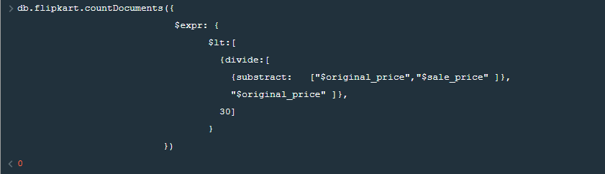

1. How many footwear products have a 50% discount?

**Ans : db.flipkart.countDocuments({**

**$and: [ { "product_category": { $eq: "footwear" } },**

**{$expr: {**

**$lt:[**

**{divide:[**

**{substract: ["$original_price","$sale_price" ]},**

**"$original_price" ]},**

**50]**

**}}]})**

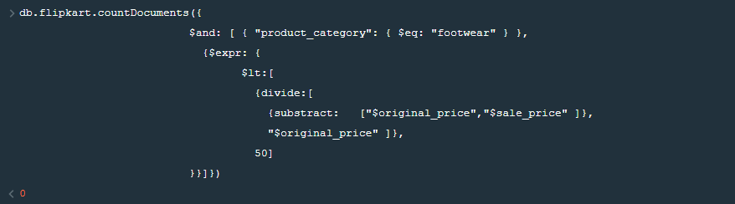

1. Which brand in Topwear section is selling the most number of products?

**Ans : Not Applicable, Becauese There is no key, value to find any type of selling history of product.**

**For example query be like: if no_of_sell present in db.**

**db.flipkart.find ({**

**$and: [ { "product_category": { $eq: "topwear" } },**

**{** **$max: "$no_of_sell"}**

**]})**